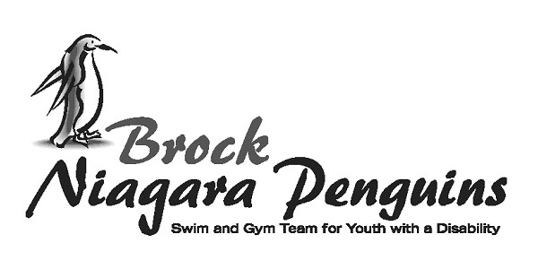
ATHLETE NEWSLETTER 2017-18

Welcome to all athletes!
Our program offers 3 sporting options:
- Swim program / Swim team
- Wheelchair Basketball
- Boccia team (Junior and Senior)

All programs strive towards improving physical activity
levels, increasing independence and providing a social
opportunity for participants.

- If you are unable to make one of the program dates, please get in touch with us. This way practice plans can be adjusted and volunteers can be informed.

- Be sure to get your completed registration forms and pay your fees at the Recreation Services Welcome Desk before the start of the first session date.

- All new athletes are required to arrange a trial visit to ensure that the program is a proper fit for both the athlete and the needs of the program.

- Please talk to Karen Natho directly if you are in need of financial assistance (email or call).

- Reminder that a parking pass (10 clip card) can be purchased from the Recreation Services Welcome Desk for $22.

- The program is run by volunteers who want to ensure the program is a success for everyone involved. Please talk to them directly or contact the designated coach / coordinator with any concerns or suggestions you may have.

1. Swim Program
If you are participating in the swim program be on the
pool deck at 4:15. Wear your bathing suit, bring a
towel, pair of goggles and a water bottle. Practice ends

at 5:30. All spectators need to watch from the observation deck. Many things are going on in the pool at once, our pool space in shared with the Olympic Way program, please be patient with everyone involved. Swim practices focus on building skills, working towards the individual goals of the participants and having FUN! Some swimmers will enter into novice swim meets, details to come. The last date in each session, is “Bring a Friend / Sibling Fun Day”! This is a day of games and activities.

Head Coach: Colin Strader

- Wheelchair Basketball Team
If you are playing on the wheelchair basketball team be outside of Gym 2 by noon. Another large program ends at 12:00, so please be patient as they clean up and leave the gym quickly, so we can begin. Wear appropriate gym clothes and running shoes. During the practice, house league games will be played. Practice ends at 2:30pm. Team members will be able to play in tournaments and training camps around Southern Ontario throughout the season.
Jim Davis will be coaching the team throughout the season.

- Boccia Ball
Junior Team, please arrive at 3:30pm in the main gym of the Niagara Children’s Centre. Senior Team, please arrive at 4:45pm. Penguin volunteers will have drills, skills and games ready each week. Competitions will be organized as they come available.
Loretta Davis will be coaching the team throughout the season.

Fundraising
The Penguins program organizes one major fundraising
initiative around the March wheelchair basketball
tournament. Details about how you can support the club by
being involved in this fundraiser will be available in the
early spring.

Penguin T-shirts
All registered athletes will be given a Penguin t-shirt during the program included in their registration fees. Additional ones can be purchased for $10.
Most communication is done via the website and through email.
If you would like any further information or have questions, do not hesitate to contact
(905) 359-6283
www.niagarapenguins.org niagarapenguins@brocku.ca

