Introductory Volunteer Newsletter 2017-18
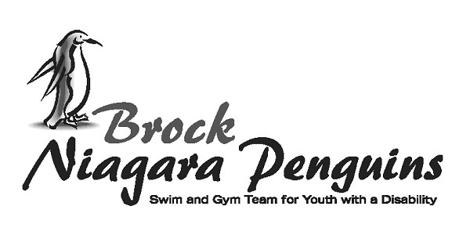

Welcome!
I would like to extend a welcome to all volunteers who have showed interest in volunteering with the Penguins.

IT IS CRUCIAL YOU READ and UNDERSTAND THIS LETTER.

This program is for youth and adults with a physical disability; our athletes have physical needs, but may also have developmental or learning disabilities. Our program consists of:
- Swim program / Swim team (Thursdays),
- Wheelchair basketball team (Saturdays and weekend travel),
- Boccia Ball – (Wednesdays)

Participants may be attending one, two or all of the programs throughout the year. All programs are striving towards improving physical activity levels, increasing independence and providing a social opportunity for participants.

The success of the program depends on you, the volunteer. It is imperative that you be on time and attend all the practices you have committed to, starting in September right through to March/April. If in an emergency you are unable to attend, you are responsible for getting in touch with your head coach immediately. Without volunteers we cannot run the program.

The majority of the helpers are volunteers from the Faculty of Applied Health Sciences and the MedPlus Program at Brock University. They are volunteering their time to ensure all athletes have a successful experience. If you have any feedback for them please talk directly to them, your head coach or Karen Natho.

- Swim Program
If you are volunteering for the swim program be on the pool deck at 4:00pm sharp. You must wear your bathing suit; you can expect to get into the water during the practice. Before practice starts please help put in the lane ropes and find out the plan for the practice from the coach who is running practice that day. Practice ends at 5:30pm, you will say goodbye to the
Page 2 on back….
swimmers and assist with any clean up that needs to be done. Volunteers will then review practice, give suggestions or any feedback for the next week. Swim practices focus on building skills and working towards the individual goals of the participants. Some swimmers will enter into novice swim meets at the end of each session, which you are encouraged to attend. A general practice plan will be posted; it is up to you to shape the practice to meet the needs of the swimmer.

Remember you set the tone of the practice, not complaining about the temperature of the water, encouraging positive behaviour from the athletes and giving simple to understand directions are key! Your energy and enthusiasm will set the stage for the swimmers to have FUN!

Each practice will be modeled around:
1. Welcome / Warm-up
2. Stretching
3. Skill
4. Fun Fitness
5. Cool down

All volunteers are encouraged to lead / develop any aspects of a practice.

- 2. Wheelchair Basketball Team Program
- If you are volunteering with the basketball program be outside of Gym 2 by 11:45am. You can go back into the storage closet and assist with getting the chairs ready. You must wear appropriate gym clothes and running shoes. You will assist with equipment set-up and find out
the plan for the practice from the coach. Practice ends at 2:30pm after a house league game.

At the end you will assist with any equipment take down, put away and clean up. All volunteers will then review the program, give suggestions or any feedback for the next week.

All volunteers are encouraged to lead / develop any aspects of a practice. The team is training for games versus other Southern Ontario wheelchair basketball teams and will attend and host camps and tournaments, that you are encouraged to help with.

3.Boccia Ball Team Program

If you are volunteering with the boccia ball program be at the Main Gym of the Niagara Children’s Centre by 3:15pm. You can go back into the gym closet and assist with set-up. You must wear appropriate gym clothes and running shoes. You will assist with equipment set-up and find out the plan for the practice from the coach. Junior practice ends at 4:30pm and Senior practice ends at 6:00pm.
Most communication is done via the website and through email.

If you would like any further information or have questions, do not hesitate to contact

(905) 359-6283
www.niagarapenguins.org
niagarapenguins@brocku.ca

Penguin T-shirts
All dedicated volunteers will be given a complimentary Penguin t-shirt during the program. Additional ones can be purchased for $10.

Working with Individuals with Disabilities

There are several things to keep in mind when working with people with a variety of different disabilities. The most important is to remember to adapt your programs or activities to each participant depending on their needs. Example, some participants may need clear step by step direction to keep them on task. Other participants may need assistance picking up equipment or adapting a game so they can participate fully. Talk to other volunteers, the athlete and perhaps their caregivers for guidance and suggestions.
As you get to know the participants and their specific strengths and abilities, adapting programs will become easier. It is important to always be patient, enthusiastic, and ensure that you are speaking to each participant in an
age-appropriate manner. Use the knowledge of the volunteers around you to help you learn what might work!

All information on the athletes and their families is confidential and not to be discussed outside Penguin sessions.

Please read the Volunteer Description, available on the website.

