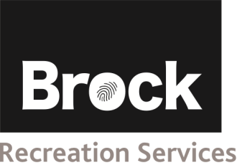

**2016-17 Athlete Application**



# Program Choice: (circle) – visit website or attached paperwork for dates and times

# *Swim ($75) – Thursdays Basketball team 1 year ($150) Boccia 1 year ($120) – Wednesdays*

# Session 1 (Sept to December) Junior Team (3:30pm-4:45pm)

# Session 2 (January to March) Senior Team (4:45pm-6:00pm)

# ATHLETE PROFILE

# Last Name:_________________ First Name: _____________________ ❑ Male ❑ Female

Physical Disability/Diagnosis:______________________________________________________________________

Date of Birth:(dd/mm/yy) _____/_____/_____ Age as of September 2016: _______

## May we use photos or videos of the athlete to promote Brock Niagara Penguins? ❑yes ❑ no

Are there any swim or recreational activities the athlete must avoid? (please specify): ______________________________________________________________________________________________

##### IMPORTANT REMINDERS

* Cheques should be payable to Brock University.
* **Print clearly when completing the application form.**
* Please note, that transportation to and from Brock University, parking, getting changed and onto the pool deck/gymnasium, toileting is the responsibility of the athlete and/or parent/guardian
* **Completed registration forms and fees must be submitted to** the Recreational Services Welcome Desk at Brock University before the start of the session (in person or on line registration system). Space is limited.

All new athletes are required to arrange a trial visit to ensure that the program is a proper fit for both the athlete and the needs of the program. If you have any questions please call (905) 688-5550 ext: 6182 or email niagarapenguins@brocku.ca.

# CONTACT INFORMATION

**Athlete’s Family Contact:**

Parent (s) Name (s): ____________________________________________

Home phone number: ____________________________________________

Work phone numbers: ____________________________________________

Cell numbers: ____________________________________________

Email Addresses: ____________________________________________

Which is the best way to contact your family: ____________________________________________

Address - Street: ________________________ City: ___________________________ Postal Code: _______________

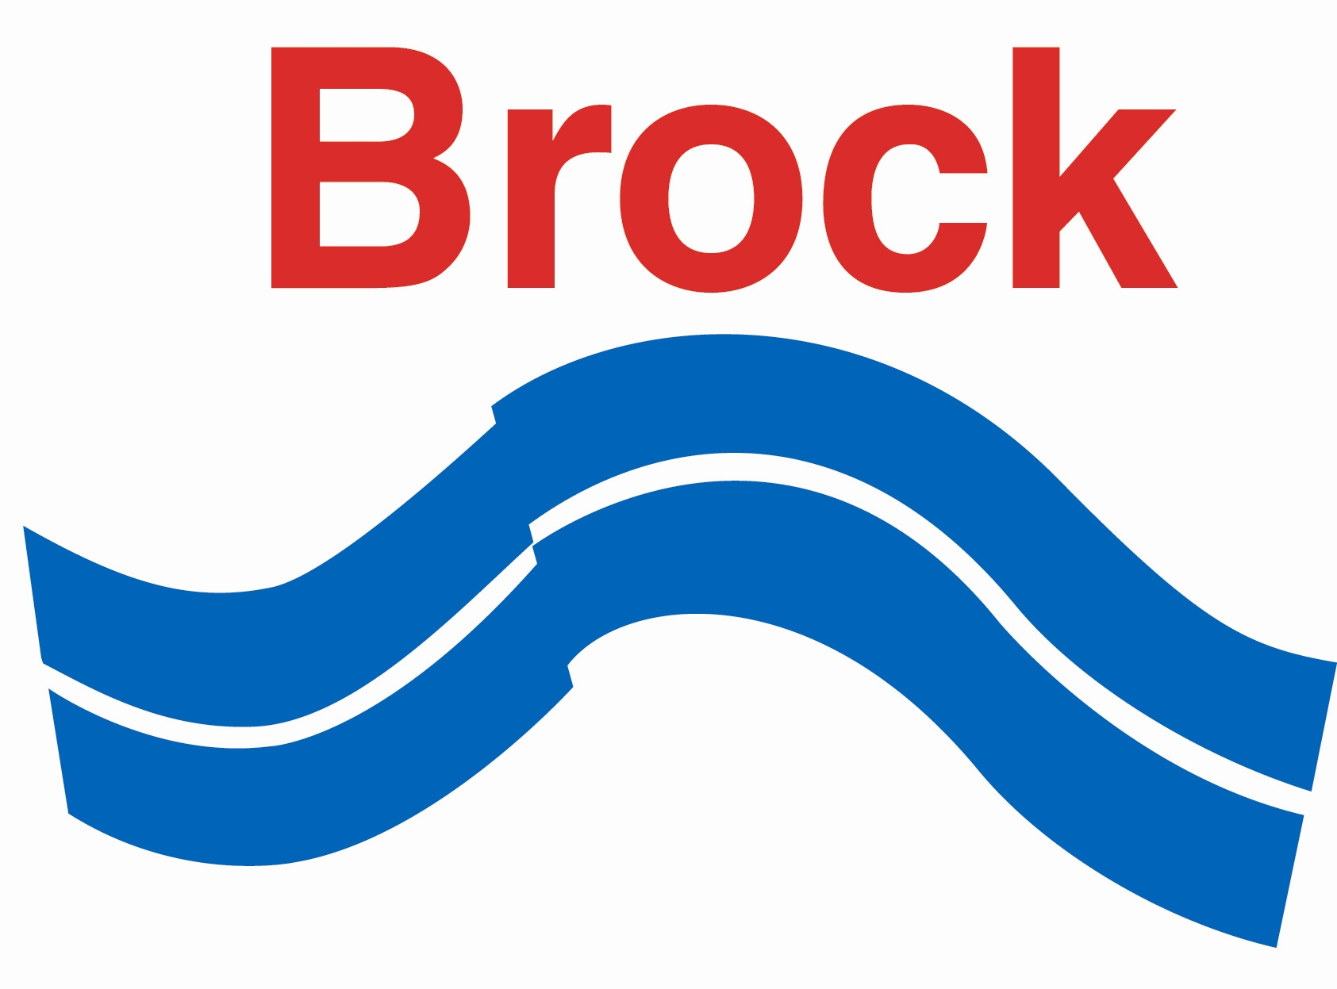

# COMMUNICATION

Verbal: ❑ yes ❑ no

Athlete understands what is said to him/her: ❑ yes ❑ no

Able to clearly express needs: ❑ yes ❑ no

Communication methods: ❑ Words ❑ Technical aids

❑ Other: ___________________________

Wears: ❑ Glasses ❑ Hearing Aids ❑ Contact Lenses

Other: _______________________________________

**MEDICAL BACKGROUND**

Please indicate medical / special needs concerns/issues that would be important in a swim / recreational setting (example: Allergies, Asthma, Seizures, Shunts):

# BEHAVIOUR

|  |
| --- |
| Check (🗸) the types of behaviour that apply to the athlete:  ❑ No unusual behaviour (proceed to next section) ❑ Physically aggressive towards others (hits, bites, etc)  ❑ Withdrawn/shy ❑ Attaches self to adults  ❑ Verbally aggressive ❑ Self injurious ❑ Wanders/runs away ❑ Other  ___________________________________________________________________________________________  Please explain any behaviours, their frequency, and methods of dealing with the behaviours: |
|  |
|  |
|  |

**SWIMMING ABILITY**

Please describe athlete’s swimming ability if registering for the swim program:

Can the athlete swim independently? ❑no ❑ yes

Does the athlete need to touch the bottom of the pool the majority of the time? ❑ no ❑ yes

Does the athlete require any assistive devices when swimming? (e.g. lifejacket): __________________________

**Athletes must provide a suitable bathing suit, water bottle, towel, lock and swim goggles for swimming.**

**All athletes will be given a club t-shirt once during the year**

**Preferred size of shirt: *(circle)* Youth S M L Adult S M L XL**

**ATHLETE’S GOALS AND INTERESTS**

Please comment on the reason for interest in the program: (e.g. recreational, get active, social, competition)

What other programs has the athlete been involved in?

What are some of the interests of the athlete?

Siblings wishing to swim at the same time and location as their brother / sister may register for the Olympic Way program through Brock Niagara Aquatic ([www.csca.org/brock](http://www.csca.org/brock)) or Brock University swimming lessons.

**CONSENT**

**I acknowledge that I have thoroughly read and understand the application form, athlete code of conduct and the new eligibility criteria.**

I acknowledge that, to the best of my knowledge, the information on this application form is correct.

I understand that this is an application for Brock Niagara Penguins and does not guarantee confirmation.

Cancellation: Refunds will only be given 2 weeks prior to the start of the session.

I agree to inform Brock Niagara Penguins of any changes in the athlete’s medical condition prior to and throughout the participation session.

I understand that a separate consent form from Recreational Services needs to be completed before the start of the program

.

Athlete’s Health Card Number:____________________ Version Code:___________

Athlete’s Signature (18 Years or older) / Parent or Guardian:____________________

Date:________________________